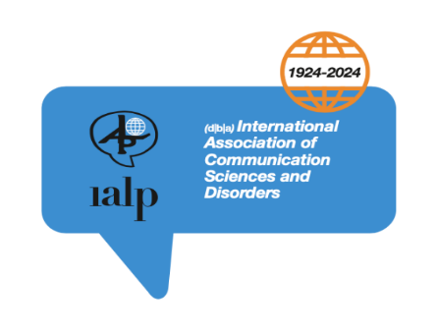01-06-2022
IALP office-32-flat1, Francesco Buhagier St. BKR1151 Malta

Dear Dr Irena Cudlinova,

I was sorry to learn that there is a possibility of a new law being passed in the Czech Republic to legalise individuals other than Speech and Language Therapists (SLTs) to be involved in the diagnosis and treatment of patients (children and adults) who have speech, language and communication disorders. This would be out of line with guidance from the World Health Organisation and OECD who recognise Speech and Language Therapy as an autonomous profession.

The International Association of Communication Sciences and Disorders (IALP) is pleased to support its Affiliated member the Associacc Klinickych Logopaedu in objecting to changing the status of those recognised as the appropriate profession to manage the treatment of a broad range of speech, language, communication and swallowing difficulties.
We would like to draw to the attention of your government that the knowledge and skills underpinning our profession lead to evidence-based practice which can ameliorate many difficulties facilitating improved education, employment and engagement of those with these difficulties.
I trust that the ministers are aware that 7.6% of children may start school with a developmental language disorder and a further 2% may start with speech and disorder associated with conditions such as cerebral palsy and autism. These difficulties frequently lead to lower levels of educational achievement, lower literacy and behaviour problems if they are unrecognised and inappropriately managed.
Furthermore, one third of those who have a cerebral vascular accident are likely to have severe communication disorders and 50% of people with neurological diseases such as Parkinson’s disease and Multiple Sclerosis are likely to develop difficulties with expressing themselves.
There is good evidence that appropriately trained Speech and Language Therapy is cost-effective.
Sincerely,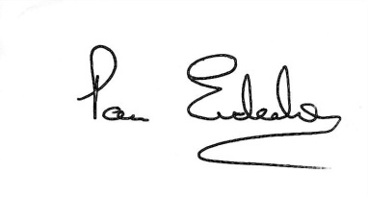 Pam Enderby OBE, PhD, DSc, FRCSLT

